  **School Of Computer Science Issue Date: _________**

**Major**

**University Of Petroleum and Energy Studies**

**P.O. Bidholi, Via-Prem Nagar DEHRADUN-248007**

**Bachelors of Technology in Computer Science &**

**Engineering Minor**

|  |  |  |  |  |  |  |  |  |  |  |
| --- | --- | --- | --- | --- | --- | --- | --- | --- | --- | --- |
| **Project Title** | | Analysis of Rubik’s Cube Solving Algorithm | | | | | **Mentor Name** | **Project Number** | | |
| Bikram Pratim Bhuyan | | |
| **S. No.** | | **Roll Number** | **Branch** | **Name** | **Role** | | | **Signature** |
| 1 | | R177219080 | B. Tech. CSE AI & ML B-3 Sem-V | Garvit Khurana |  | | |  |
| 2 | | R177219191 | B. Tech. CSE AI & ML B-6 Sem-V | Tanya Malhotra |  | | |  |
| 3 | | R177219194 | B. Tech. CSE AI & ML B-6 Sem-V | Utkarsh Gupta |  | | |  |
| 4 | | R177219196 | B. Tech. CSE AI & ML B-6 Sem-V | Vanshaj Goel |  | | |  |

_____________________________________________________ __________________________________________________

|  |  |  |
| --- | --- | --- |
| **Project Mentor** |  | **Head Of Department** |

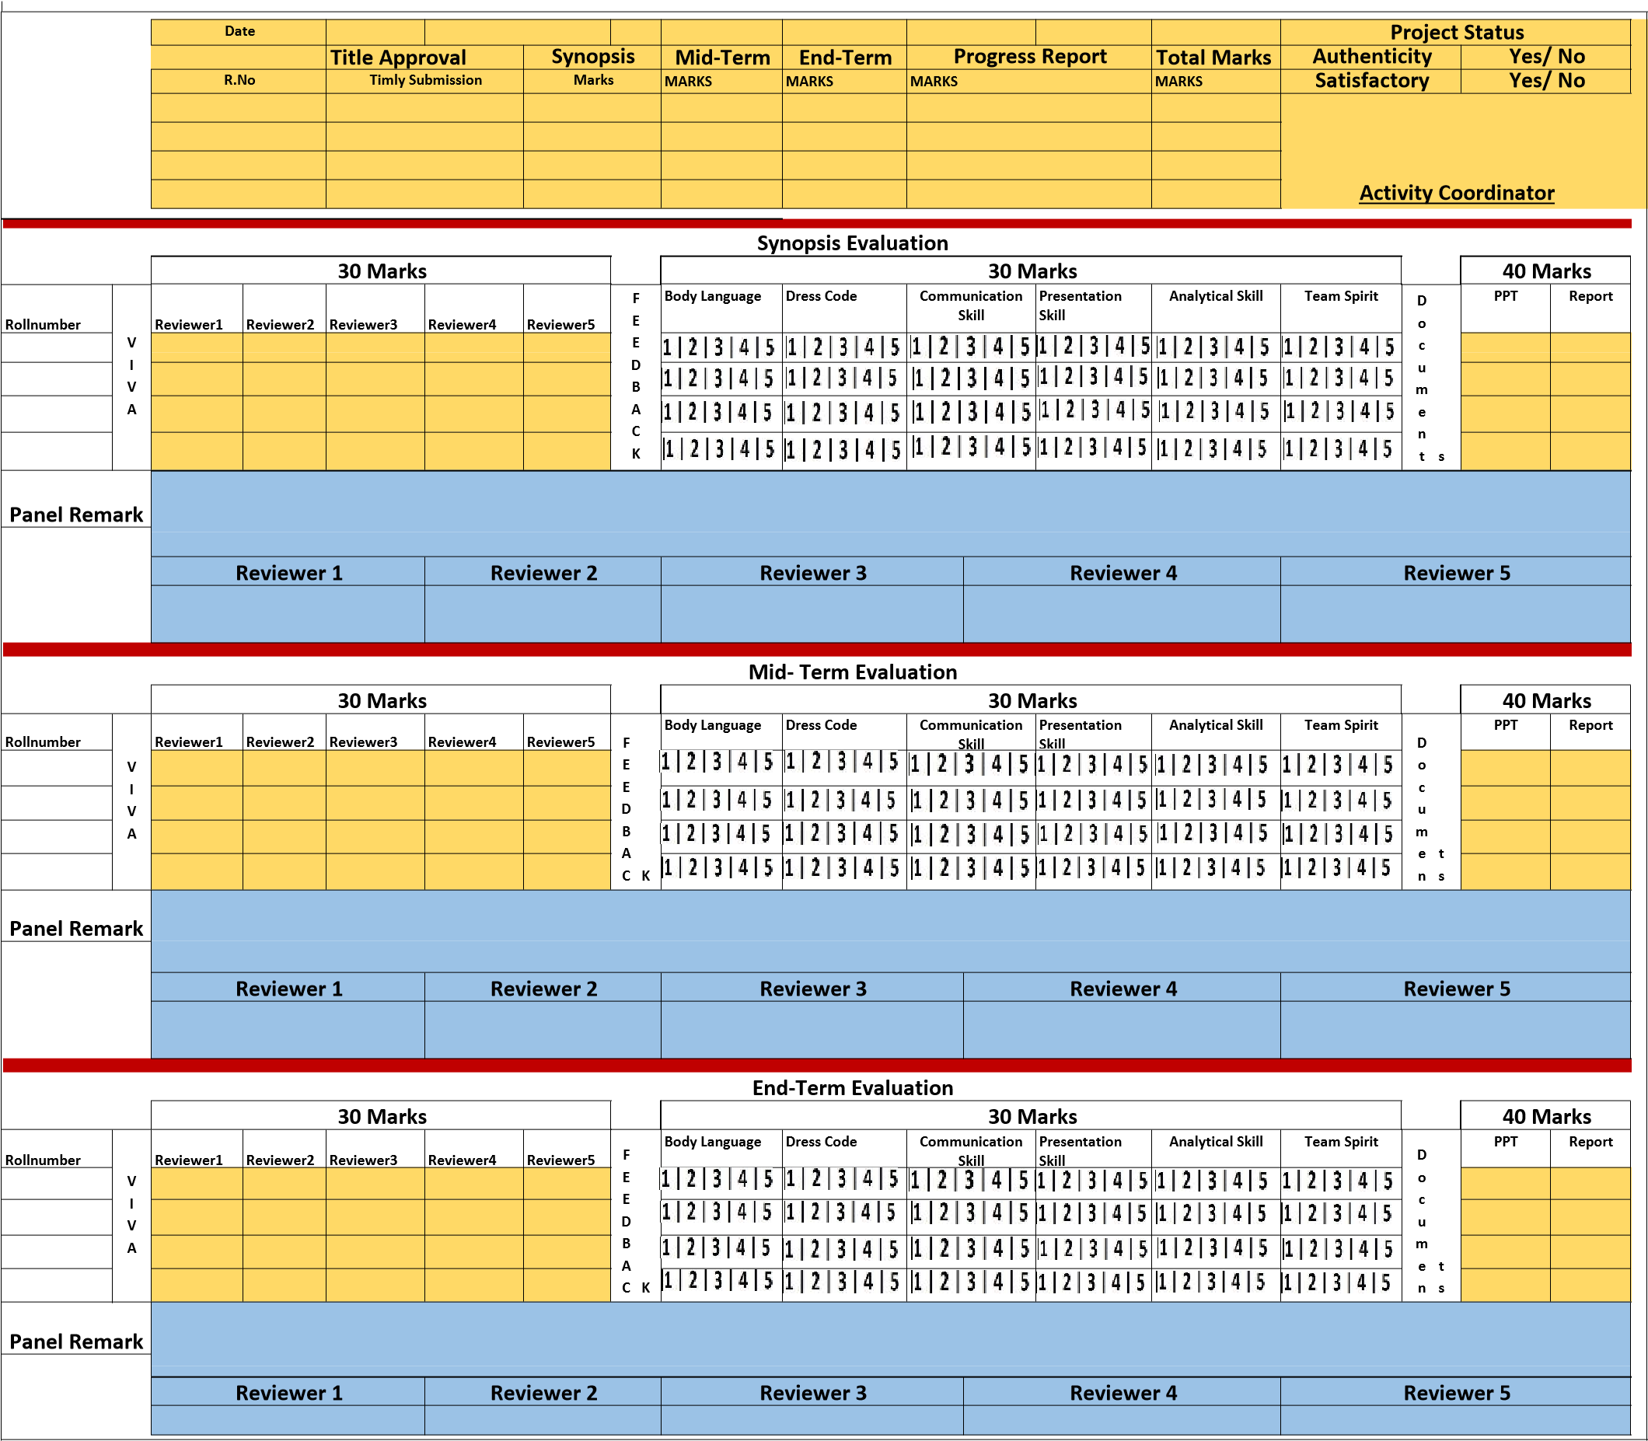

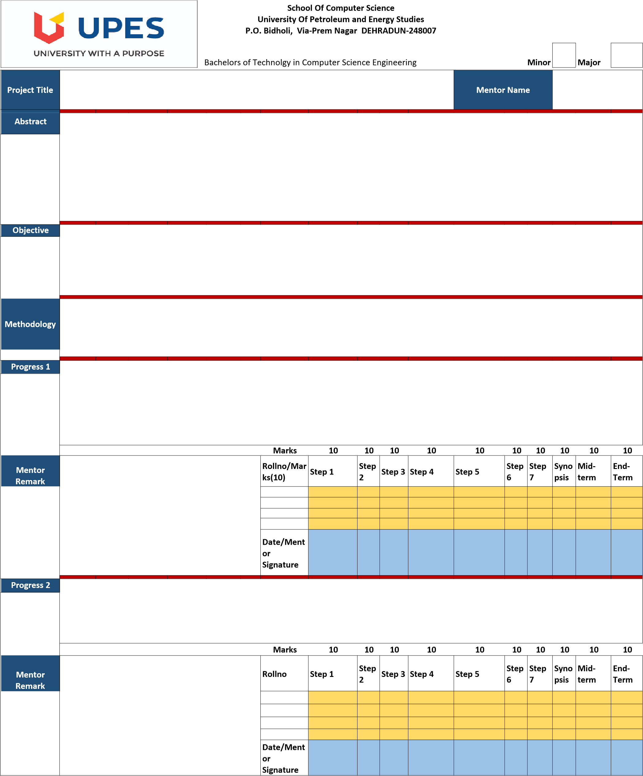

**Guideline: 1)** A project group can be of maximum 4 members and no alteration in the group member will be entertained later.

**Guideline: 2)** Methodology should have following steps Step1: Literature Review; Step2: Identification Of Requirement (Type Of Data source, Amount Of Data, & Format of Data); Step3: Identification of Algorithm; Step 4 : Comparative study; Step5: Design and Development of System/Architecture; Step 6: Implementation; Step7: Results **Guideline:3)** Student should upload softcopies of all the documents (reports and power point presentations) in “Project Directory”, 24 hrs prior to evaluation. **Guideline:4)** Panel member will give feedback to individual on the scale of 1 to 5 and this scale will change for defaulter i.e. 1 to 3 scale.

1: Poor 2: Average 3: Good 4: Excellent 5: Outstanding